All images analysis was conducted by matlab. ANOVA conducted by R. All source code is included in the folder. Because of packages and environment settings, the code needs to be adjusted a little bit to run.

1, Image analysis for NaCl with CaCl2 and MgCl2. In this experiment, particles size (area in image) was used to quantify components concentrations. Parameters RGB to blackwhite threshold is 0.95 (im2bw function). Parameter for noise removing is 6(medfilt2 function).

**Table 1** Samples concentration table (because of limited space, only one sample of each group shown in this table)

|  |  |  |  |
| --- | --- | --- | --- |
|  | NaCl 10 mM (sample 1) | NaCl 5.0 mM (sample 6) | NaCl 2.5mM (sample 11) |
| CaCl2 3.0 mM  MgCl2 1.5 mM |  |  |  |

**Figure 1** Image analysis results (Samples 1-5 are NaCl 10 mM with CaCl2 3.0 mM and MgCl2 1.5 mM, samples 6-10 are NaCl 5.0 mM with CaCl2 3.0 mM and MgCl2 1.5 mM, samples 11-15 are NaCl 2.5 mM with CaCl2 3.0 mM and MgCl2 1.5 mM.

After selection the best hyperparameter. Images were processed by using the chosen parameters and an ANOVA test was used to test differences between different concentrations samples. According to the test result, the p-value is 0.0004128, which means the difference is significant that samples could be distinguished by different groups.

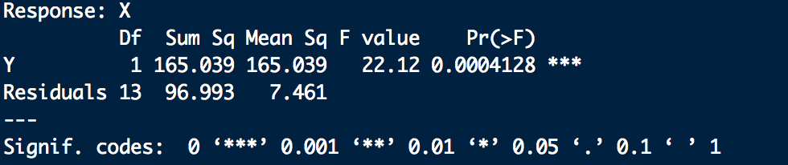

**Figure 2** Boxplot for particles area

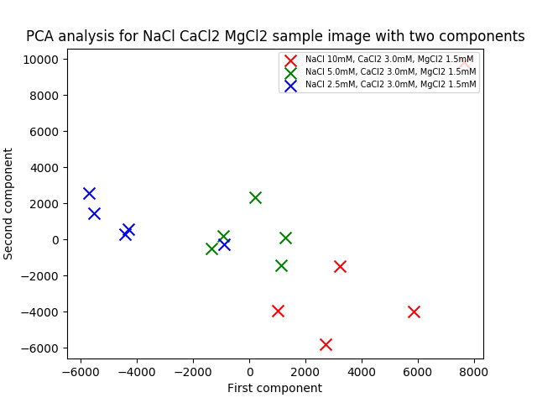

**Figure 3** PCA analysis for NaCl CaCl2 MgCl2 sample image with two components

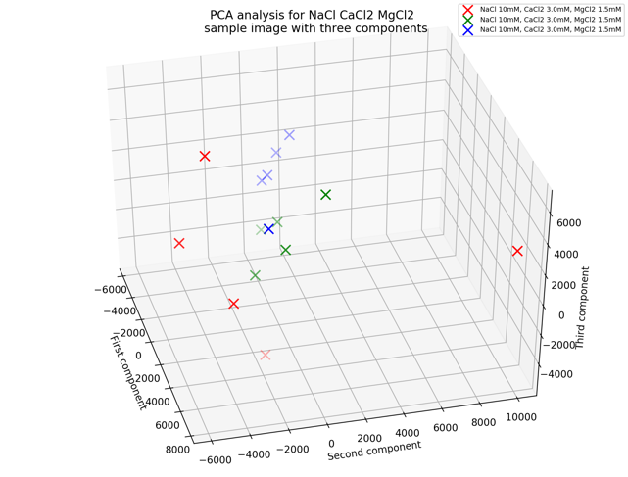

**Figure 4** PCA analysis for NaCl CaCl2 MgCl2 sample image with three components

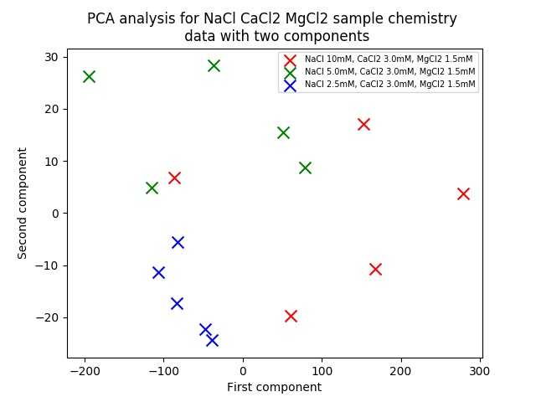

**Figure 5** PCA analysis for NaCl CaCl2 MgCl2 sample chemistry data with two components

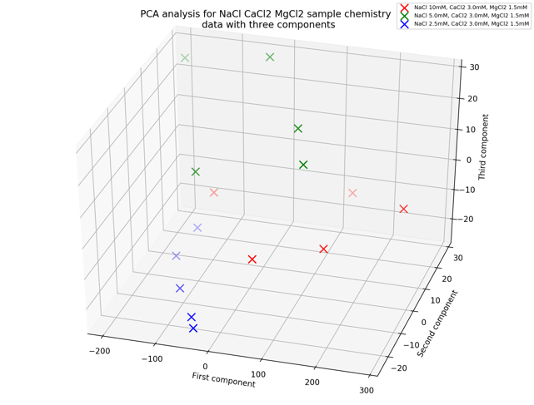

**Figure 6** PCA analysis for NaCl CaCl2 MgCl2 sample chemistry data with three components

According to the PCA analysis figure, samples could be separated by first 2 components very well except one outlier sample.

2, Image analysis for NaHCO3 with CaCl2 and MgCl2. In this experiment, particles number was used to quantify components concentrations. Parameters RGB to blackwhite threshold is 0.89(im2bw function). Parameter for noise removing is 11(medfilt2 function).

**Table 2** Samples concentration table (because of limited space, only one sample of each group shown in this table)

|  |  |  |  |
| --- | --- | --- | --- |
|  | NaHCO3 10 mM (sample 1) | NaHCO3 5.0 mM (sample 7) | NaHCO3 2.5mM (sample 11) |
| CaCl2 0.5 mM  MgCl2 0.25 mM |  |  |  |

**Figure 7** Image analysis results (Samples 1-5 are NaHCO3 10 mM with CaCl2 0.5 mM and MgCl2 0.25 mM, samples 6-10 are NaHCO3 5.0 mM with CaCl2 0.5 mM and MgCl2 0.25 mM, samples 11-15 are NaHCO3 2.5 mM with CaCl2 0.5 mM and MgCl2 0.25 mM.

After selection the best hyperparameter. Images were processed by using the chosen parameters and an ANOVA test was used to test differences between different concentrations samples. According to the test result, the p-value is 0.001719, which means the difference is significant that samples could be distinguished by different groups.

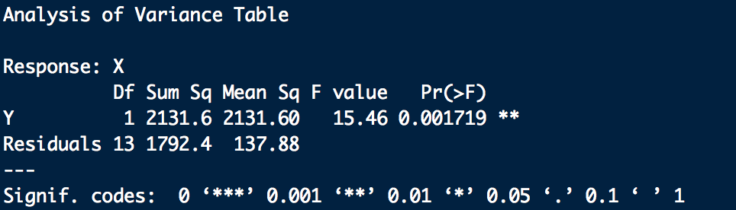

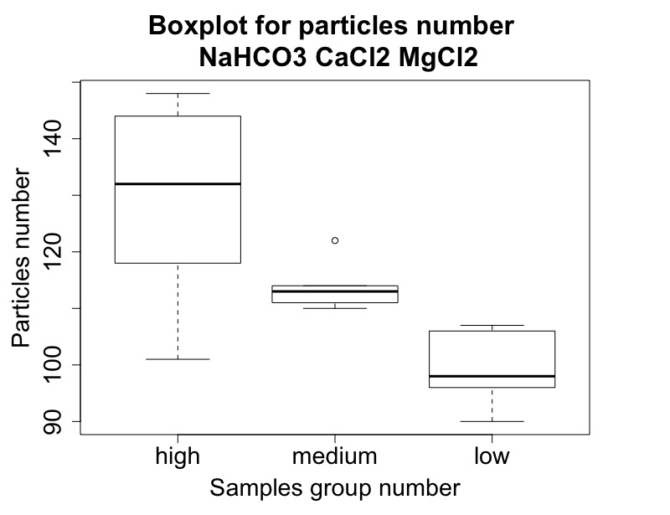

**Figure 8** Boxplot for particles number

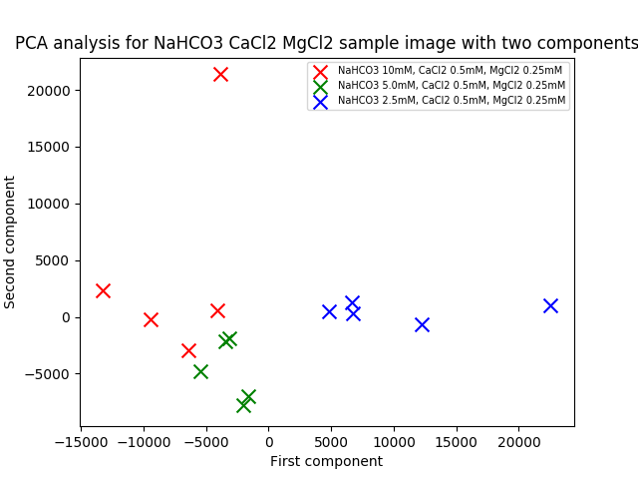

**Figure 9** PCA analysis for NaHCO3 CaCl2 MgCl2 sample image with two components

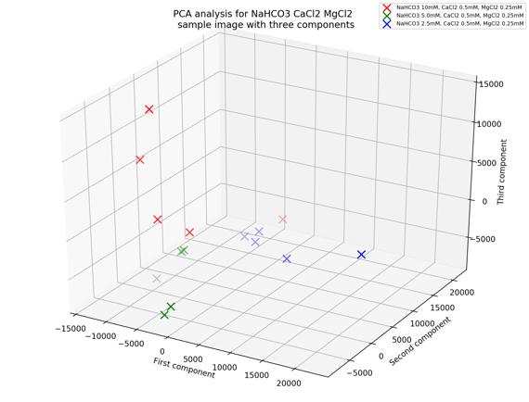

**Figure 10** PCA analysis for NaHCO3 CaCl2 MgCl2 sample image with three components

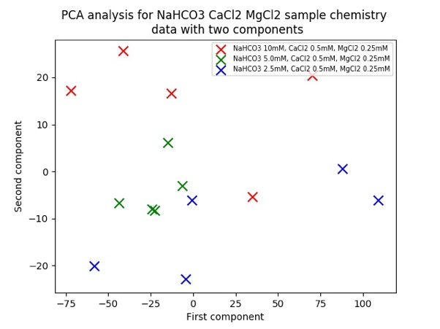

**Figure 11** PCA analysis for NaHCO3 CaCl2 MgCl2 sample chemistry data with two components

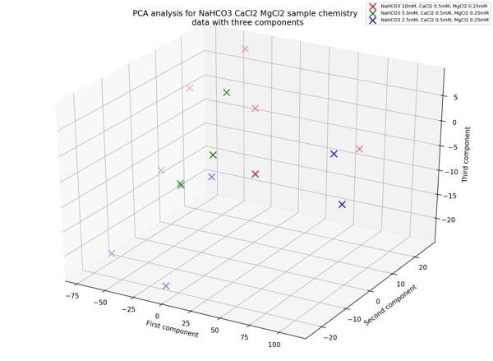

**Figure 12** PCA analysis for NaHCO3 CaCl2 MgCl2 sample chemistry data with three components

According to PCA analysis figure, samples could be separated by first 2 components except one outlier sample.

3, Image analysis for Na2SO4 with CaSO4 and MgSO4. In this experiment, particles number was used to quantify components concentrations. Parameters RGB to blackwhite threshold is 0.85(im2bw function). Parameter for noise removing is 9(medfilt2 function).

**Table 3** Samples concentration table (because of limited space, only one sample of each group shown in this table)

|  |  |  |  |
| --- | --- | --- | --- |
|  | Na2SO4 10 mM (sample 1) | Na2SO4 5.0 mM (sample 6) | Na2SO4 2.5mM (sample 11) |
| CaSO4 0.5 mM  MgSO4 0.25 mM |  |  |  |

**Figure 13** Image analysis results (Samples 1-5 are Na2SO4 10 mM with CaSO4 0.5 mM and MgSO4 0.25 mM, samples 6-10 are Na2SO4 5.0 mM with CaSO4 0.5 mM and MgSO4 0.25 mM, samples 11-15 are Na2SO4 2.5 mM with CaSO4 0.5 mM and MgSO4 0.25 mM.

After selection the best hyperparameter. Images were processed by using the chosen parameters and an ANOVA test was used to test differences between different concentrations samples. According to the test result, the p-value is 1.596*10-6, which means the difference is significant that samples could be distinguished by different groups.

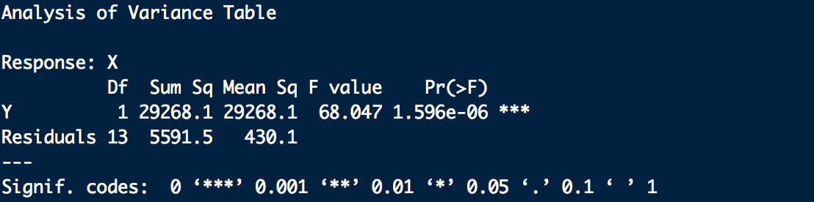

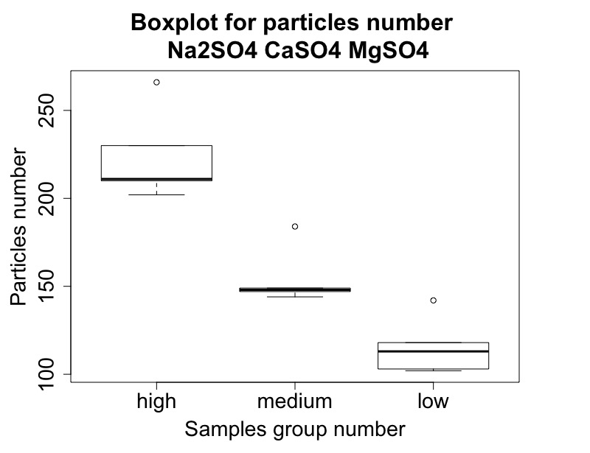

**Figure 14** Boxplot for particles number

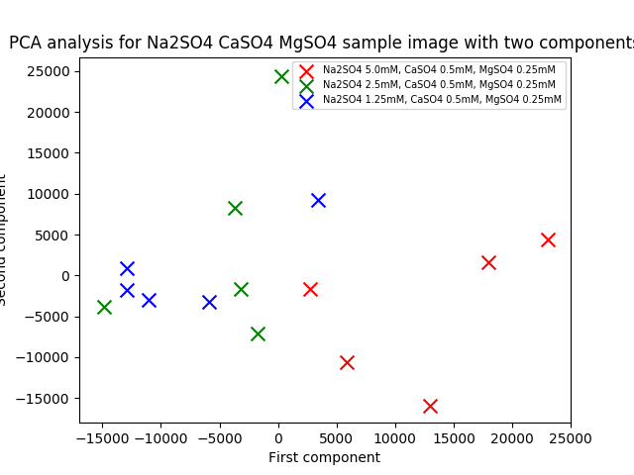

**Figure 15** PCA analysis for Na2SO4 CaSO4 MgSO4 sample image with two components

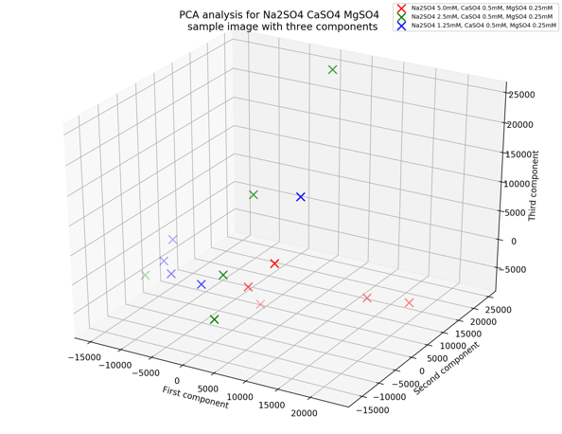

**Figure 16** PCA analysis for Na2SO4 CaSO4 MgSO4 sample image with three components

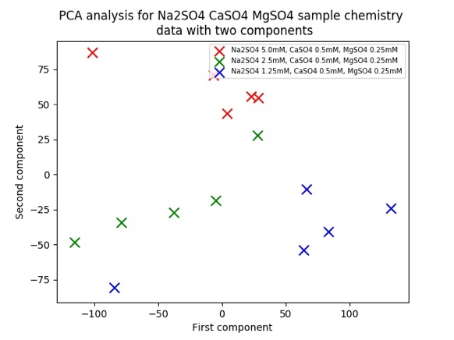

**Figure 17** PCA analysis for Na2SO4 CaSo4 MgSO4 sample chemistry data with two components

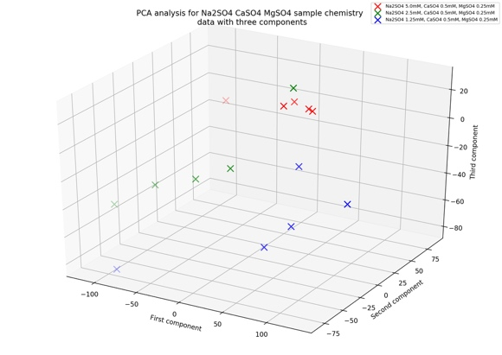

**Figure 18** PCA analysis for Na2SO4 CaSO4 MgSO4 sample chemistry data with three components

According to PCA analysis figure, the result to distinguish these samples is not good.

4, Image analysis for NaHCO3 with CaSO4 and MgSO4. In this experiment, particles number (area in image) was used to quantify components concentrations. Parameters RGB to blackwhite threshold is 0.93 (im2bw function). Parameter for noise removing is 6 (medfilt2 function).

**Table 4** Samples concentration table (because of limited space, only one sample of each group shown in this table)

|  |  |  |  |
| --- | --- | --- | --- |
|  | NaHCO3 10 mM (sample 1) | NaHCO3 5.0 mM (sample 7) | NaHCO3 2.5mM (sample 12) |
| CaSO4 0.5 mM  MgSO4 0.25 mM |  |  |  |

**Figure 19** Image analysis results (Samples 1-5 are NaHCO3 10 mM with CaSO4 0.5 mM and MgSO4 0.25 mM, samples 6-10 are NaHCO3 5.0 mM with CaSO4 0.5 mM and MgSO4 0.25 mM, samples 11-15 are NaHCO3 2.5 mM with CaSO4 0.5 mM and MgSO4 0.25 mM.

After selection the best hyperparameter. Images were processed by using the chosen parameters and an ANOVA test was used to test differences between different concentrations samples. According to the test result, the p-value is 0.0005984, which means the difference is significant that samples could be distinguished by different groups.

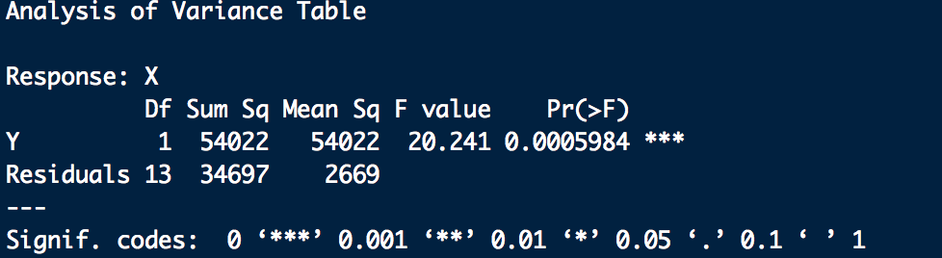

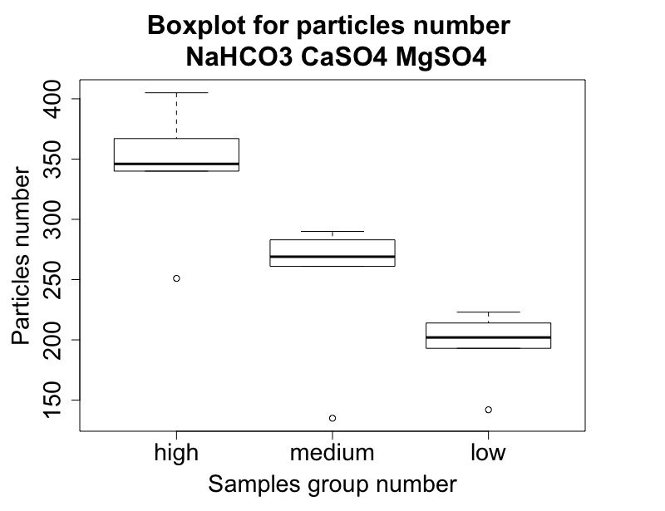

**Figure 20** Boxplot for particles number

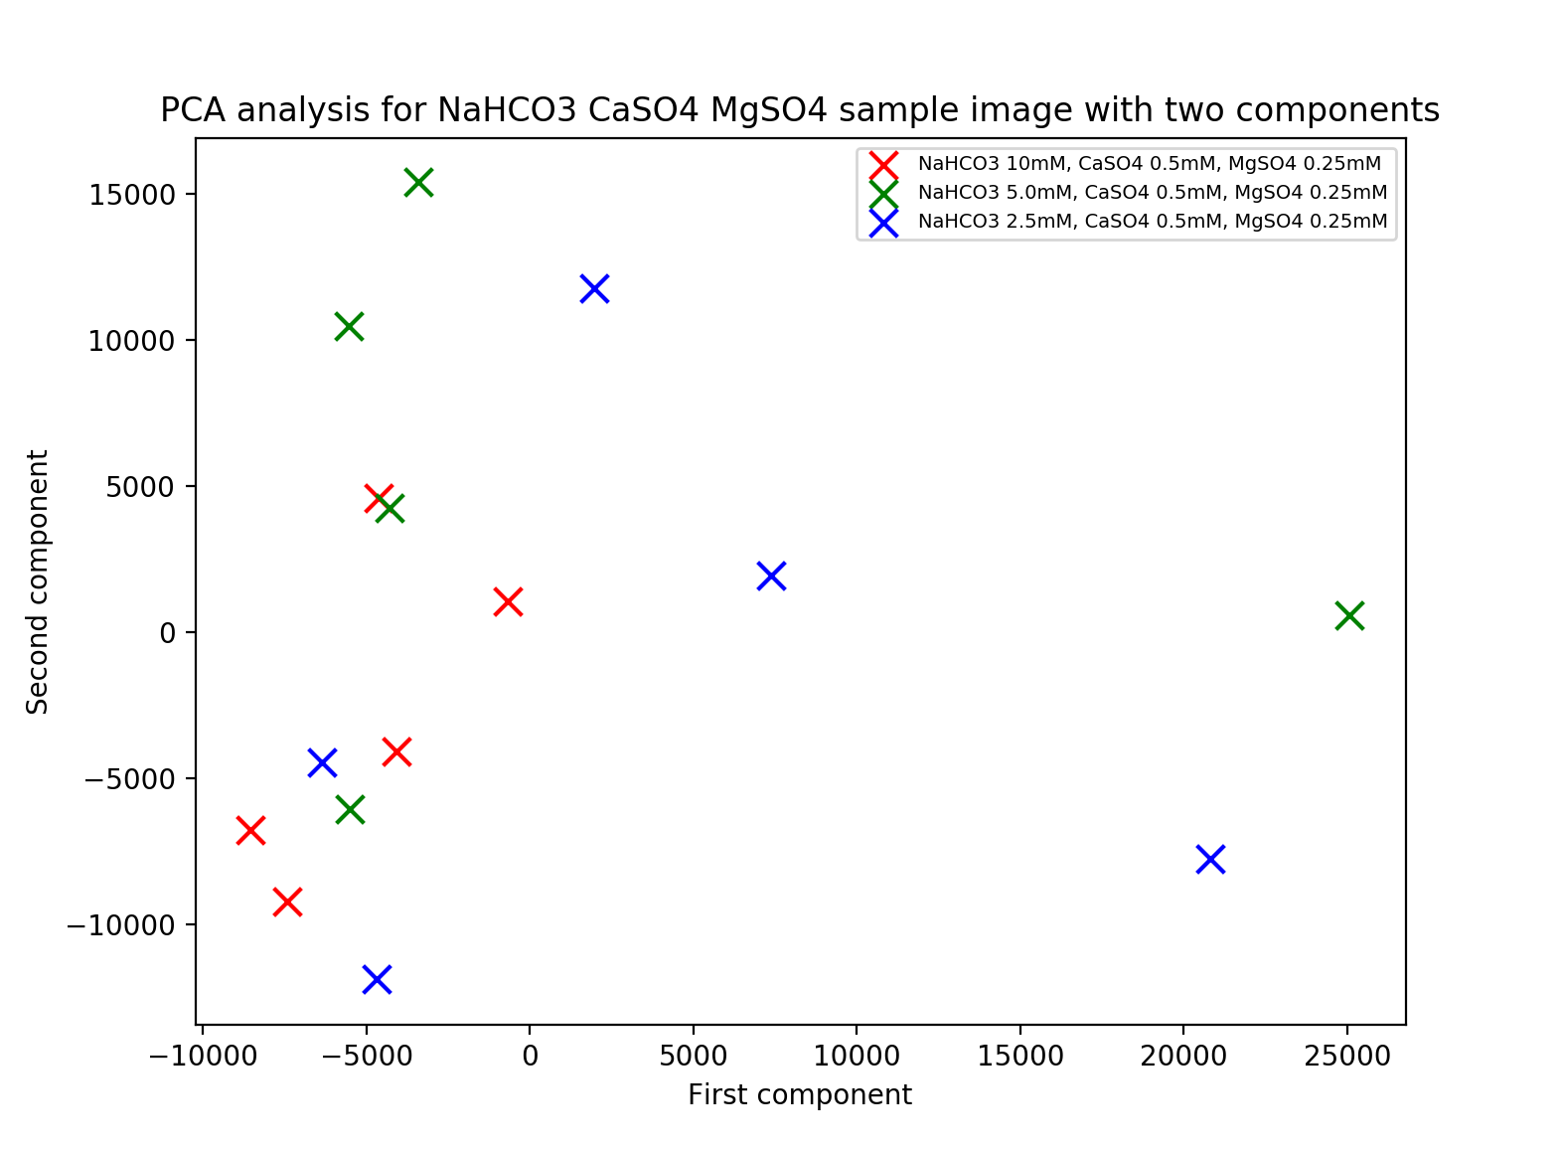

**Figure 21** PCA analysis for NaHCO3 CaSO4 MgSO4 sample image with two components

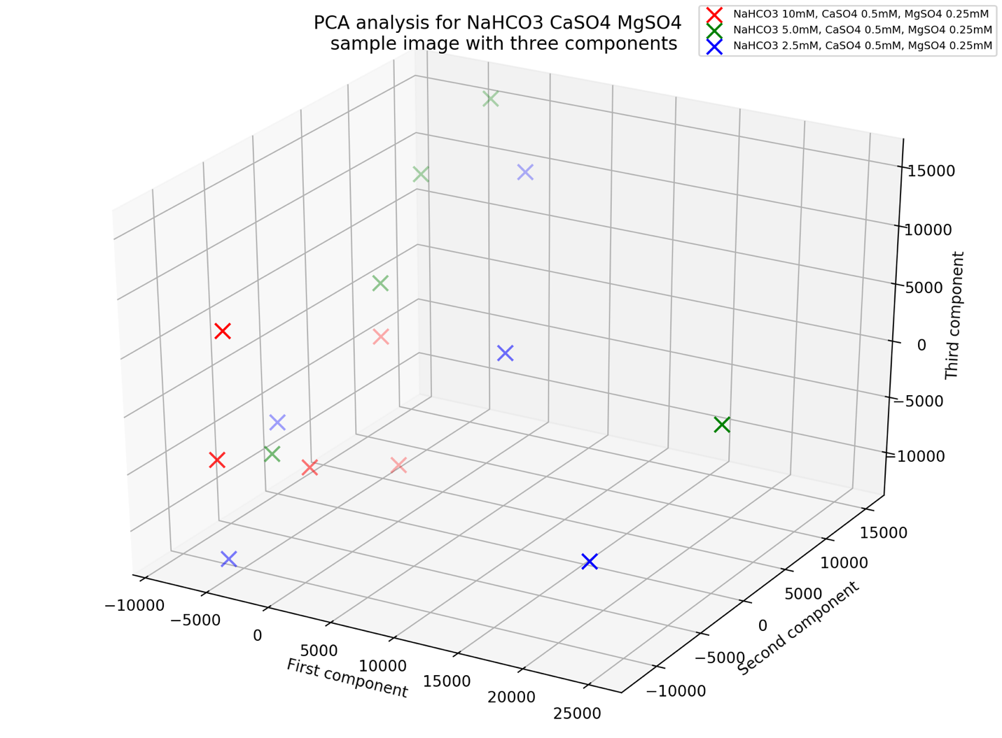

**Figure 22** PCA analysis for NaHCO3 CaSO4 MgSO4 sample image with three components

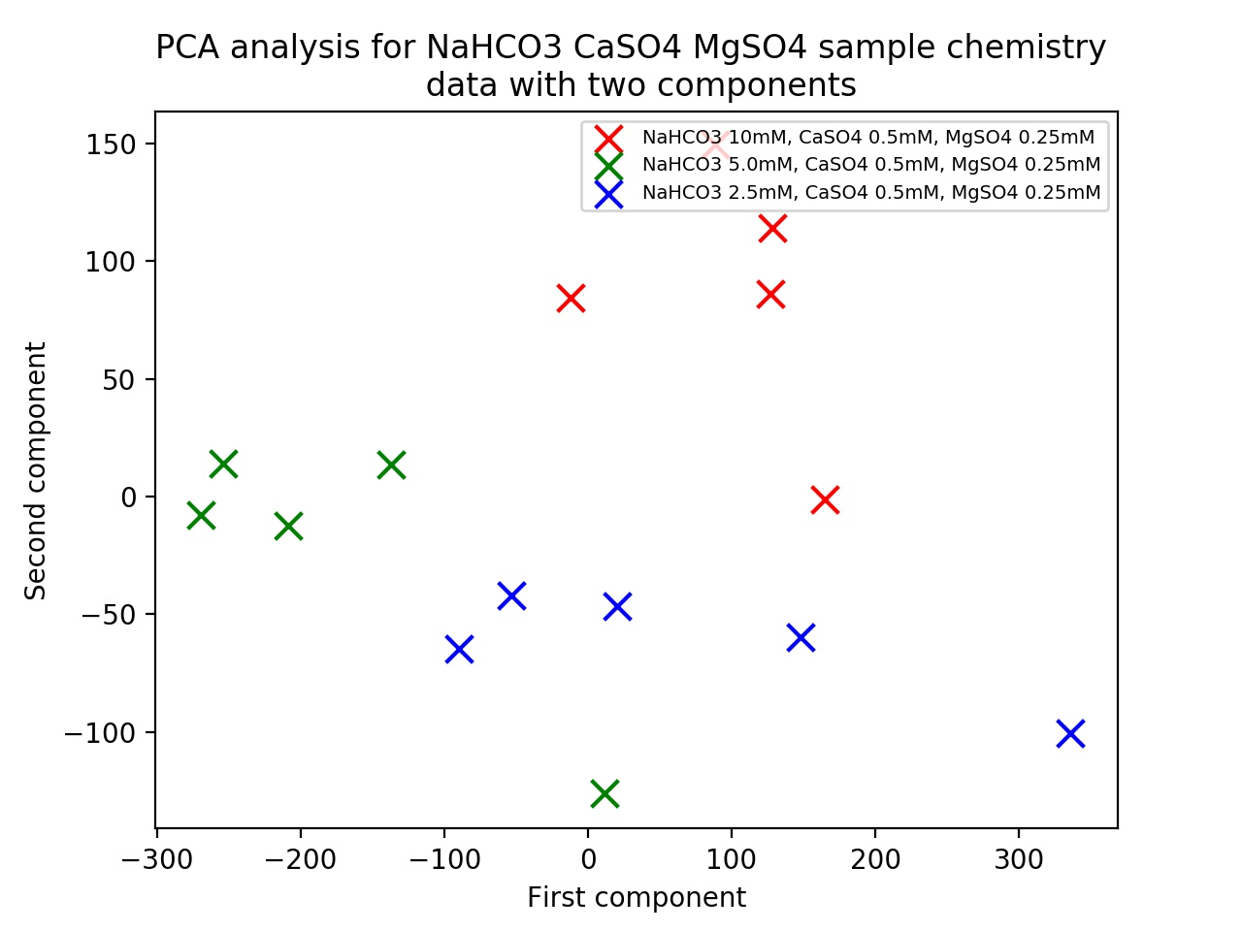

**Figure 23** PCA analysis for NaHCO3 CaSO4 MgSO4 sample chemistry data with two components

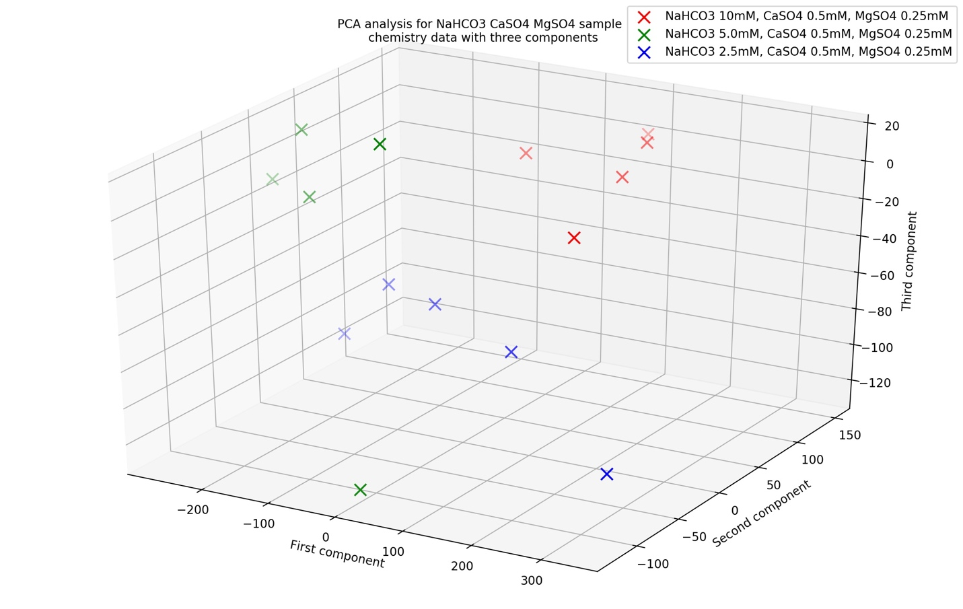

**Figure 24** PCA analysis for NaHCO3 CaSO4 MgSO4 sample chemistry data with three components

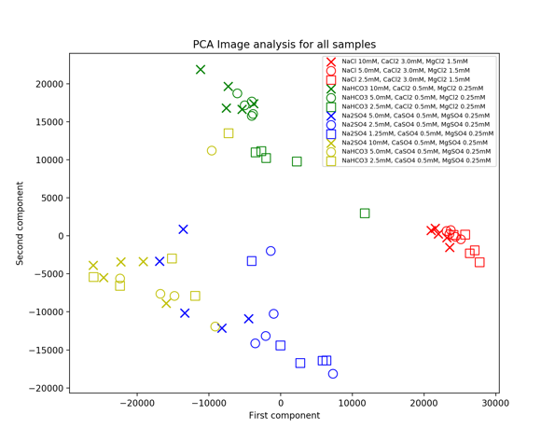

**Figure 25** PCA Image analysis for all sample of first and second components

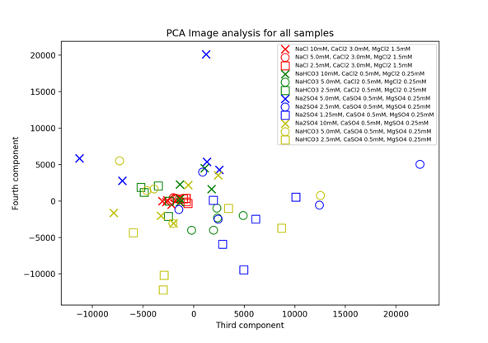

**Figure 26** PCA Image analysis for all sample of third and fourth components

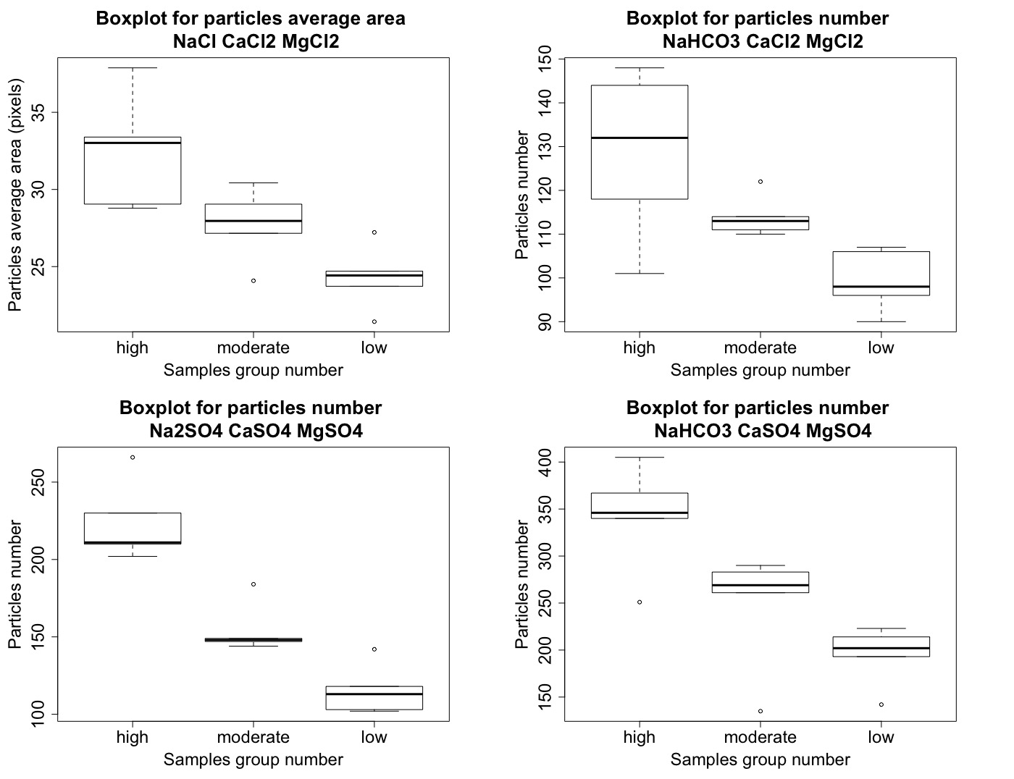

**Figure 27** Box plot for all four experiments

|  |  |  |  |  |
| --- | --- | --- | --- | --- |
|  | NaCl 10 mM (sample 1) | NaCl 5.0 mM (sample 6) | NaCl 2.5mM (sample 11) | Particle area 20-40 |
| CaCl2 3.0 mM  MgCl2 1.5 mM |  |  |  |  |

|  |  |  |  |  |
| --- | --- | --- | --- | --- |
|  | NaHCO3 10 mM (sample 1) | NaHCO3 5.0 mM (sample 7) | NaHCO3 2.5mM (sample 11) | Particle number 90-150 |
| CaCl2 0.5 mM  MgCl2 0.25 mM |  |  |  |  |

|  |  |  |  |  |
| --- | --- | --- | --- | --- |
|  | Na2SO4 10 mM (sample 1) | Na2SO4 5.0 mM (sample 6) | Na2SO4 2.5mM (sample 11) | Should say particles number. 100-250 |
| CaSO4 0.5 mM  MgSO4 0.25 mM |  |  |  |  |

|  |  |  |  |  |
| --- | --- | --- | --- | --- |
|  | NaHCO3 10 mM (sample 1) | NaHCO3 5.0 mM (sample 7) | NaHCO3 2.5mM (sample 12) | Should say particles number. 150-400 |
| CaSO4 0.5 mM  MgSO4 0.25 mM |  |  |  |  |

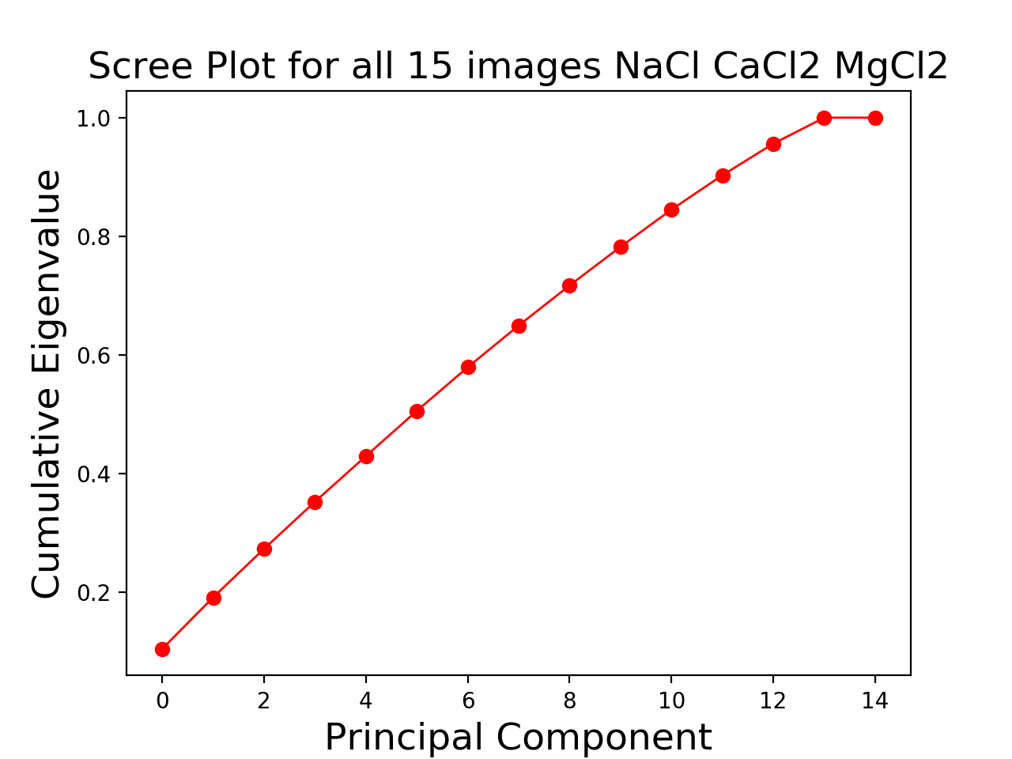

**Figure 28** Scree plot for NaCl CaCl2 MgCl2

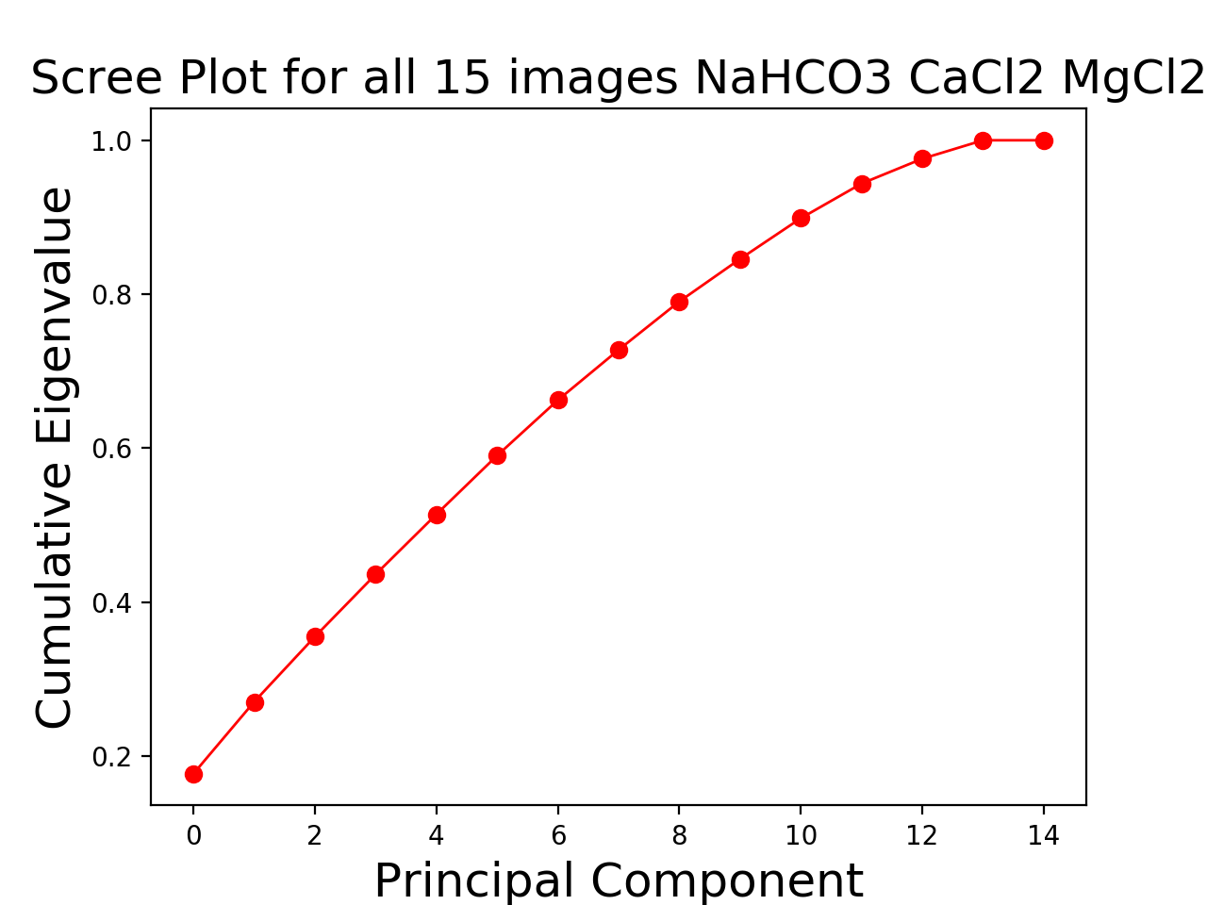

**Figure 29** Scree plot for NaHCO3 CaCl2 MgCl2

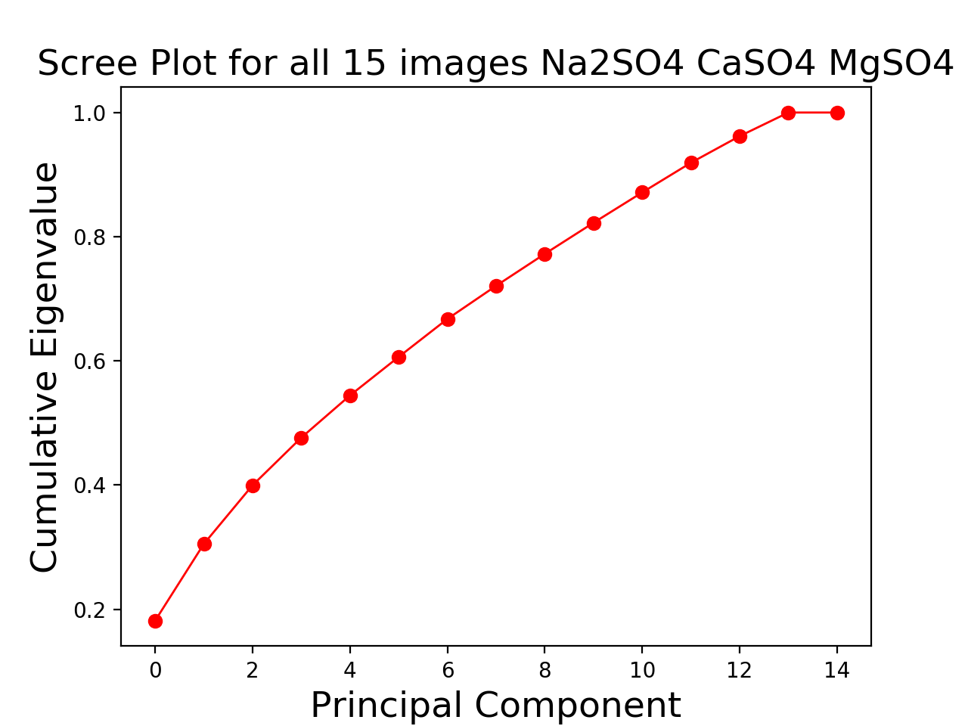

**Figure 30** Scree plot for Na2SO4 CaSO4 MgSO4

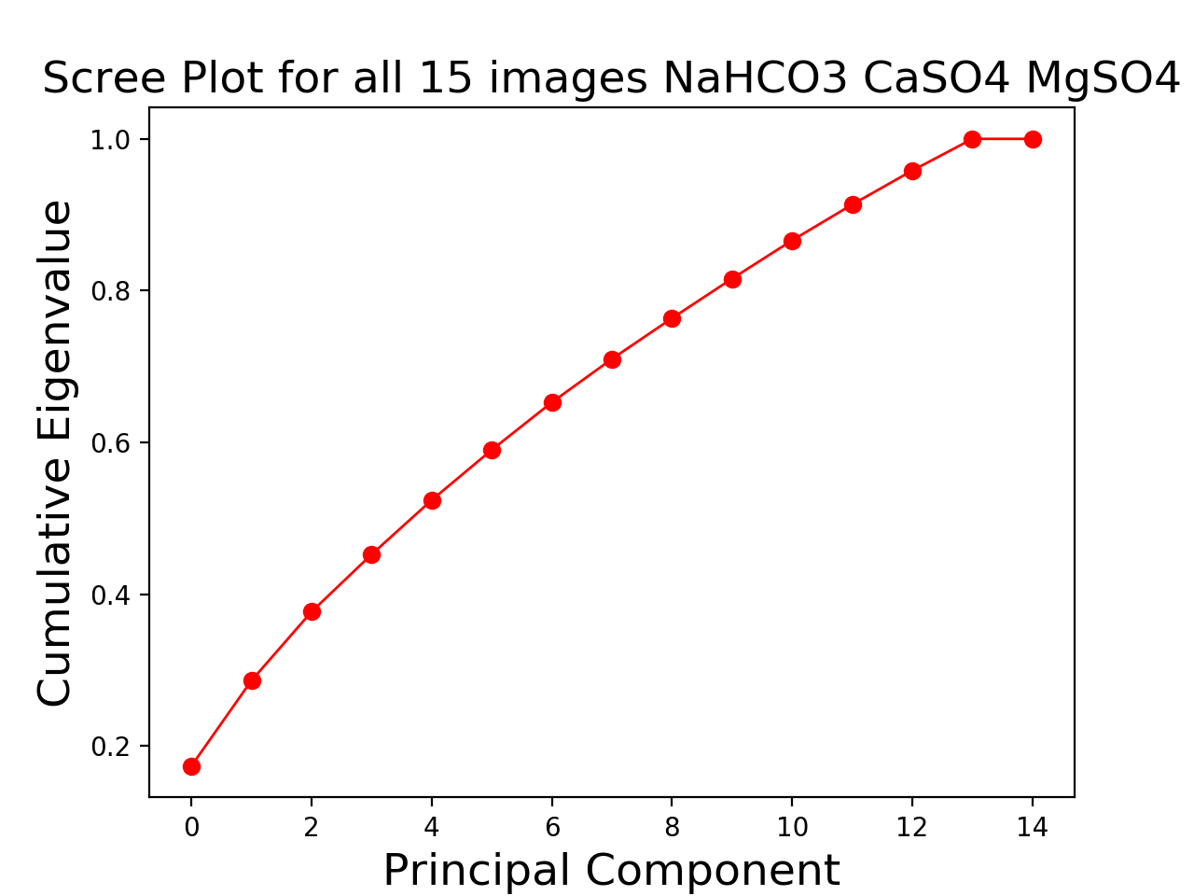

**Figure 31** Scree plot for NaHCO3 CaSO4 MgSO4